Bank Loan Analysis Report Query

--Total Bank Total loan application --

select count(id) as Total_Loan_Application from bankdata

Result: 

-- Total Month-to-Date Bank loan applications--

select

count(id) as MTD_Toal_Loan_Applications from bankdata

where month(issue_date)=12 and year(issue_date)=2021

Result: 

--Total Previous MTD Bank Loan Applications--

select

count(id) as PMTD_Total_Loan_Application from Bankdata

where month(issue_date) =11 and year(issue_date)=2021

Result: 

-- Total Funded Amount--

select

sum(loan_amount)

as Total_funded_amount from Bankdata

Result: 

-- Month-to-date Total Funded Amount--

select

sum(loan_amount) as MTD_Total_Funded_Amount

from Bankdata

where month(issue_date)=12 and year(issue_date)=2021

Result: 

-- Total Previous Month-to-Date Funded amount--

select

sum(loan_amount) as PMTD_Total_Funded_Amount from Bankdata

where month(issue_date)=11 and year(issue_date)=2021

Result: 

--Total Amount Received--

select

sum(total_payment) as Total_Amount_Received

from Bankdata

Result: 

-- Month-to-date Total Amount Received--

select

sum(total_payment) as MTD_Total_Amount_Received

from Bankdata

where month(issue_date)=12 and year(issue_date)=2021

Result: 

--Previous Month-to-date Total Amount Received--

select

sum(total_payment) as PMTD_Total_Amount_Received

from Bankdata

where month(issue_date)=11 and year(issue_date)=2021

Result: 

-- Average Interest rate--

select

ROUND(avg(int_rate)*100,2) as Average_Int_Rate

from Bankdata

Result: 

-- Month-to-date Average Interest rate--

select

ROUND(avg(int_rate)*100,2) as MTD_Average_Int_Rate

from Bankdata

where month(issue_date)=12 and year(issue_date)=2021

Result: 

--Previous Month-to-date Average Interest rate--

select

ROUND(avg(int_rate)*100,2) as PMTD_Average_Int_Rate

from Bankdata

where month(issue_date)=11 and year(issue_date)=2021

Result: 

--Average Debt-to-Income Ratio--

select

ROUND(avg(dti)*100,2) as Average_DTI

from Bankdata

Result: 

--Month-to-date Average Debt-to-Income Ratio--

select

ROUND(avg(dti)*100,2) as MTD_Average_DTI

from Bankdata

where month(issue_date)=12 and year(issue_date)=2021

Result: 

--Previous Month-to-date Average Debt-to-Income Ratio--

select

ROUND(avg(dti)*100,2) as PMTD_Average_DTI

from Bankdata

where month(issue_date)=11 and year(issue_date)=2021

Result: 

--Good Loan Application Percentage--

select

(count(case when loan_status = 'Fully Paid' or loan_status = 'Current' then id end )*100

/

Count(id)) as Goodloan_Applications_Percentage

from Bankdata

Result: 

--Total Good Loan Applications--

select

count(case when loan_status = 'Fully Paid' or loan_status = 'Current' then id end )

as Total_Good_loan_Applications

from Bankdata

Result: 

--Total Good Loan Funded Amount--

select

sum(case when loan_status = 'Fully Paid' or loan_status = 'Current' then loan_amount end )

as Total_Good_loan_Amount

from Bankdata

Result: 

--Total Good Loan Funded Amount Received--

select

sum(case when loan_status = 'Fully Paid' or loan_status = 'Current' then total_payment end )

as Total_Good_loan_Amount_Received

from Bankdata

Result:

--Bad Loan Application Percentage--

select

(count(case when loan_status = 'Charged off' then id end )*100

/

Count(id)) as Bad_loan_Applications_Percentage

from Bankdata

Result:

--Total Bad Loan Applications--

select

count(case when loan_status = 'Charged off' then id end )

as Total_Bad_loan_Applications

from Bankdata

Result:

--Total Bad Loan Funded Amount--

select

sum(case when loan_status = 'Charged off' then loan_amount end )

as Total_Bad_loan_Amount

from Bankdata

Result:

--Total Bad Loan Funded Amount Received--

select

sum(case when loan_status = 'Charged off' then total_payment end )

as Total_Bad_loan_Amount_Received

from Bankdata

Results: 

-- Loan status grid view--

select

Loan_status,

count(id) as Total_Loan_Application,

sum(loan_amount) as Total_loan_funded_amount,

sum(total_payment) as Total_loan_amount_received,

round(avg(int_rate*100),2) as AVG_Interest_rate,

round(avg(dti*100),2) as Avg_Debt_to_Income_rate

from Bankdata

group by loan_status

Result: 

-- Loan status grid view MTD, --

select

loan_status,

sum(loan_amount) as MTD_loan_amount_funded,

sum(total_payment) as MTD_total_amount_received

from bankdata

where month(issue_date)=12

group by loan_status

Result: 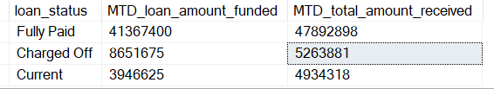

--Monthly Trends of issue date--

select

Month(issue_date) as Month_Number,

Datename(Month, issue_date) as Month_Name,

count(id) as Total_Loan_Application_received,

sum(loan_amount) as Total_Loan_Amount_funded,

sum(total_payment) as Total_Loan_Amount_Received

from Bankdata

group by Month(issue_date),Datename(Month, issue_date)

order by Month(issue_date) asc

Result: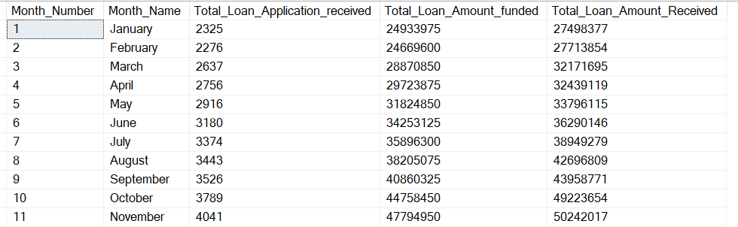

--Regional Analysis by State--

select

address_state as State,

count(id) as Total_Loan_Application_received,

sum(loan_amount) as Total_Loan_Amount_funded,

sum(total_payment) as Total_Loan_Amount_Received

from Bankdata

group by address_state

Result: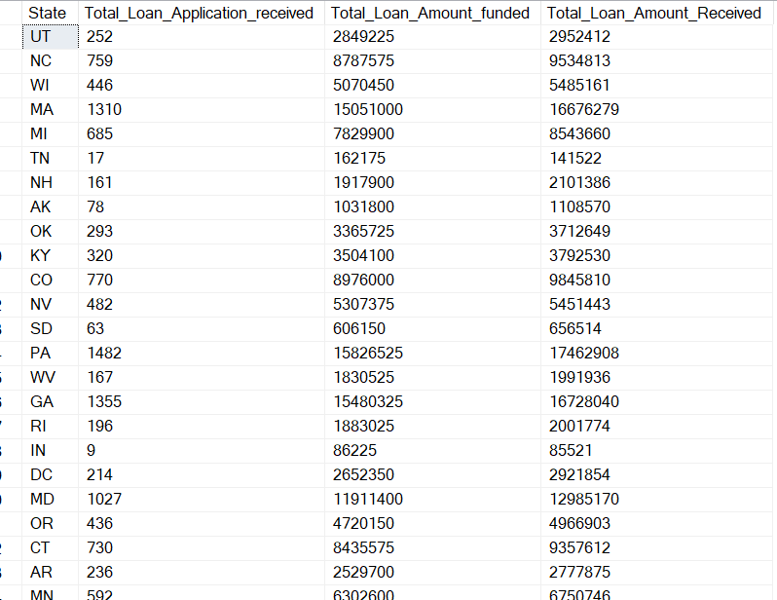

-- Loan Term Analysis--

select

term,

count(id) as Total_Loan_Application_received,

sum(loan_amount) as Total_Loan_Amount_funded,

sum(total_payment) as Total_Loan_Amount_Received

from Bankdata

group by term

order by term asc

Result:

-- Employee Length Analysis –-

select

emp_length,

count(id) as Total_Loan_Application_received,

sum(loan_amount) as Total_Loan_Amount_funded,

sum(total_payment) as Total_Loan_Amount_Received

from Bankdata

group by emp_length

order by emp_length asc

Result: 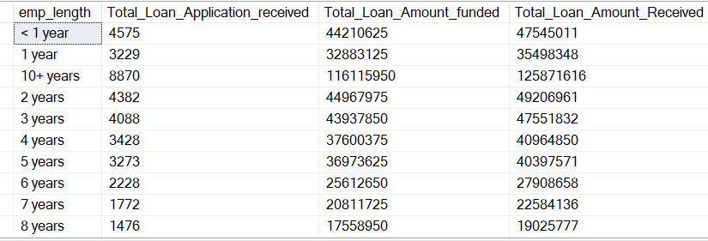

--Loan Purpose Breakdown--

select

purpose,

count(id) as Total_Loan_Application_received,

sum(loan_amount) as Total_Loan_Amount_funded,

sum(total_payment) as Total_Loan_Amount_Received

from Bankdata

group by purpose

Result: 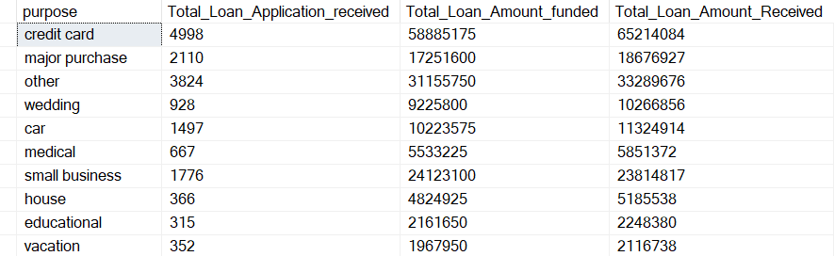



--Home Ownership Analysis --

select

home_ownership,

count(id) as Total_Loan_Application_received,

sum(loan_amount) as Total_Loan_Amount_funded,

sum(total_payment) as Total_Loan_Amount_Received

from Bankdata

group by home_ownership

Result: 